Compliance
- Students may complete their compliance document requirements at any lab or facility of their choosing. The information provided below is offered solely as a reference for commonly used facilities; students are not required to utilize the options below and may find another lab or facility.
- It is the student's responsibility to ensure that they are receiving the correct tests to fulfill compliance requirements. Students are responsible for the costs and to inquire with the specific facility if they are eligible to use their own health insurance.
Health First Medical Center
Dr. Stephen Canowitz, MD
5969 E. Broad Street, Suite 407
Columbus, Ohio 43213
614-762-2166 (call to make an appointment)

Services offered:
- History & physical (must be done on a MCCN History and Physical form found on Project Concert’s homepage).
- QuantiFERON blood test (instead of doing 2-step PPD)
- Urine drug Screen
- MMR, varicella, hepatitis B titers

CVS Minute Clinc
Nationwide
Can schedule online

Services offered:
- Clinic services differ based on location. Recommend calling first for availability.
- History & physical (must be done on a MCCN History and Physical form found on Project Concert’s homepage).
- QuantiFERON blood test (instead of doing 2-step PPD)
- 2-step PPD
- Urine drug Screen
- MMR, varicella, hepatitis B titers
- Most vaccinations (varicella, MMR, Tdap and hep B).

Quest Laboratory
Nationwide
Questhealth.com NOT questdiagnostics.com
Blood and urine tests must be done in person and not done as an at home collection. At home collections will not be accepted by the college.
Students need to purchase any needed tests below (this will vary by each student based on each individual student’s medical history and vaccination status/previous titer results). Once the needed tests have been purchased online through questhealth.com, the student will then use the online scheduler to make an appointment to have their tests completed. Once the student has the results, they will then upload them in Project Concert for verification. It is the student’s responsibility to access and obtain their own results through the respective portal provided by Quest.

Services offered:
- MMR titers (called “Measles, Mumps, Rubella (MMR) test”)
- Varicella titers (called “Chickenpox Test”)
- QuantiFERON blood test (instead of doing 2-step PPD) (called “Tuberculosis Blood Test”)
- Urine drug screen (called “Drug Screening Test Panel- Expanded”).
- Important Note: Hepatitis B does not have its own titer test through Quest. If you need a hepatitis B titer, please purchase “Vaccination Status Test Panel”. You may not need to purchase individual varicella and MMR titers if you purchase the “Vaccination Status Test Panel” since that’s included in this test. “Vaccination Status Test Panel” does not include a Tuberculosis/QuantiFERON blood test.
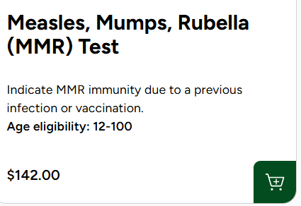
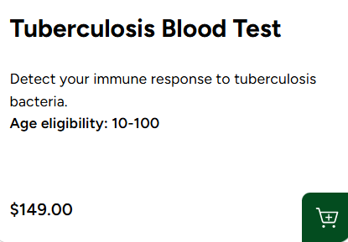
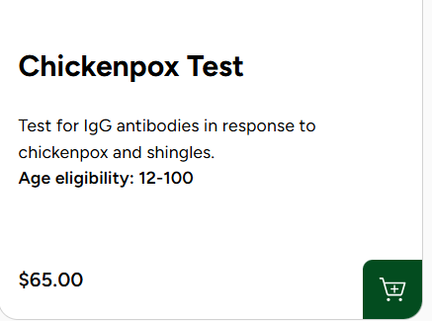

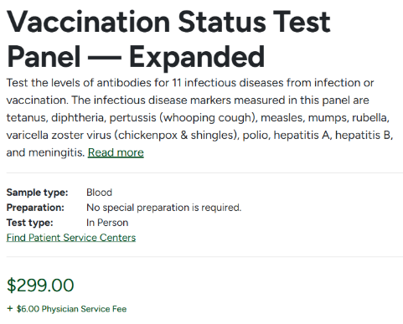
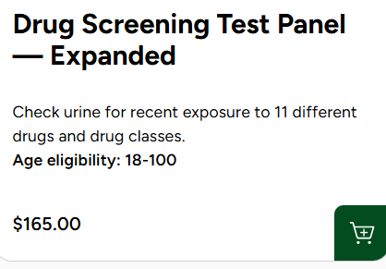

LabCorp
Nationwide
https://www.ondemand.labcorp.com/ NOT lapcorp.com
Blood and urine tests must be done in person and not done as an at home collection. At home collections will not be accepted by the college.
Students need to purchase any needed tests below (this will vary by each student based on each individual student’s medical history and vaccination status/previous titer results). Once the needed tests have been purchased online through ondemand.lapcorp.com, the student will then use the online scheduler to make an appointment to have their tests completed. Once the student has the results, they will then upload them in Project Concert for verification. It is the student’s responsibility to access and obtain their own results through the respective portal provided by LapCorp.

Services offered:
- MMR titers (called “Measles, Mumps, Rubella (MMR) test”)
- Varicella titer (called “Chickenpox Immunity Test”)
- QuantiFERON blood test (instead of doing 2-step PPD) (called “Tuberculosis (TB) Blood Test”)
- Urine drug screen (called “Complete Drug test”).
- Important Note: You may want to select “Standard Immunity Test” which contains varicella, MMR and hepatis B titers. This may be more cost effective for you depending on what titers you need done.

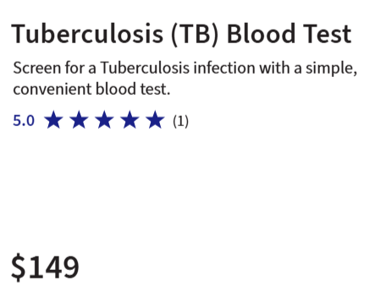
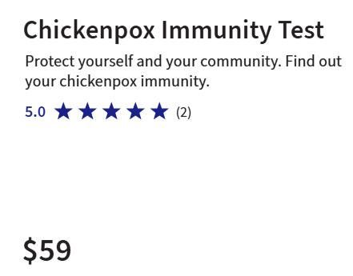
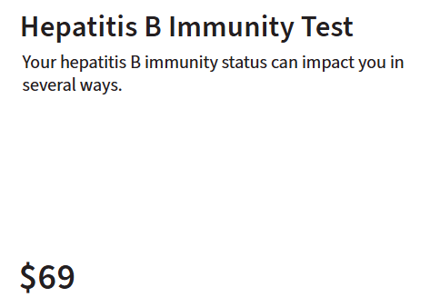

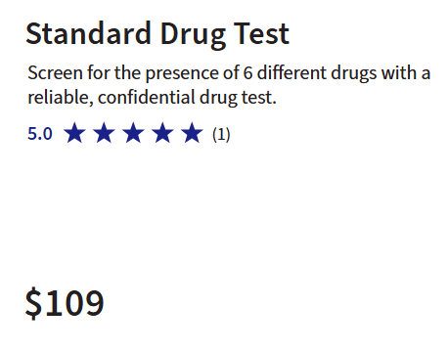
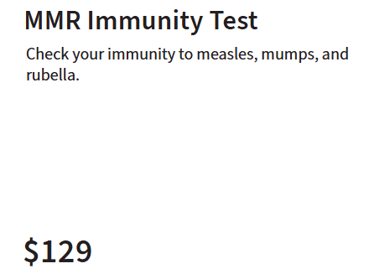
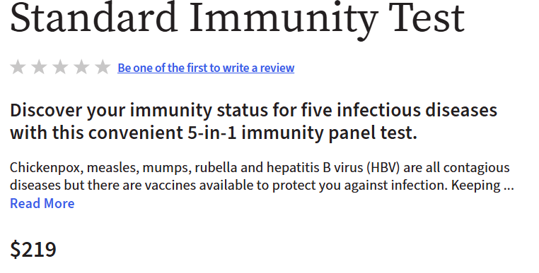

ARCPoint Labs
Nationwide
https://www.arcpointlabs.com/

Services offered:
- MMR titers (called “Measles, Mumps, Rubella (MMR) Screening”)
- Varicella titer (called “Varicella-Zoster Virus Antibody (IgG)”)
- QuantiFERON blood test (instead of doing 2-step PPD) (called “QuantiFERON Tuberculosis (TB) Screening”)
- Urine drug screen (called “Drug Test- 10 Panel Urine (Rapid)”). Get immediate results.
- Some locations also do background checks, vaccinations and history and physicals. Recommend calling to inquire about the specific location as each location may differ. You will likely need to make an appointment.
