Capstone Orientation Instructions
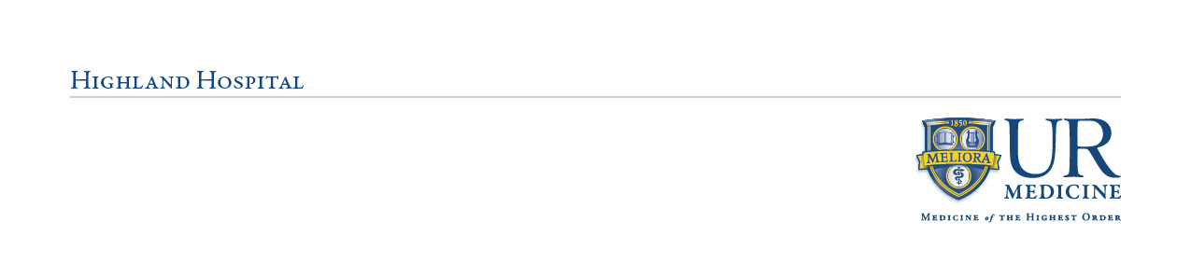
Capstone Orientation Checklist

Set up URMC account (if new to Highland)
Get access to eRecord and complete class, if applicable
Review orientation packet and complete post-test (keep for your records)

Review RASON skills checklist
Py Reach out to your preceptor to plan your schedule
Py Send parking and ID information to Support Services
Pick up HH ID Badge and finalize parking in Support Services
Have a meaningful experience and please follow all hospital policies!
Complete an evaluation at the end of your capstone experience

Additional Details
- For students new to UR facilities, please watch for emails from URID-NoReply@urmc.rochester.edu and eRecordSchedulingEnrollment@notices.rochester.edu to set up your account and access eRecord training
- Before your first day, send the following to hhservline@urmc.rochester.edu:
  - JPEG/PNG headshot with name and role
  - Completed parking registration form (regardless of parking status)
- Either before or on your first day, go to Support Services on the 1st floor to:
  - Obtain your Highland Hospital ID badge (refer to note below*). For URMC employees, bring your ID badge. For all others, bring a form of ID.
  - Set up parking, as applicable. If you already pay for parking at any UR affiliate, please let Support Services know and you can park on-campus. Please have available your UR ID or parking permit, license plate, make & model, color, and year of your vehicle.
*Note: It is the responsibility of students and faculty instructors to always wear Highland ID badges and school ID badges while on site. The replacement fee for Highland ID badges is $25. At the end of the semester, please return badge to Support Services.
- On your first day, have your preceptor help you access PolicyStat. Please familiarize yourself with the following policies: “Addendum T - Role & Responsibilities of Nursing Students” and “Students at Clinical Sites, 1.13”

If you have questions, please don’t hesitate to reach out. Welcome to Highland!
Highland Hospital
Nursing Professional Development
A002
(585)341-6709

